Balance Sheets:

Balance Sheets Definition:
- It summarizes , , and
- Helps businesses and investors .

The Balance Sheet Formula

Formula Definitions:

Why is the balance sheet important?

Income Statement:
- Equation:
Introduction
Imagine that you are interested in buying a business. What information would you want to see? The income statement summarizes much of the information that you would want to know before you would buy a business such as revenues, expenses, and net income.

In this lesson, students will learn how income statements are constructed for both service and merchandising businesses and how to calculate component percentages.
The income statement is the backbone of fundamental analysis for investors and the cornerstone for sound management decisions. This lesson is rigorous in content to support students as future investors and decision makers.
Key Terms:

Term | Definition
Video Questions: Income Statement Questions 1 - 6
Got to the class webpage and watch the video on Income Statements found on your tube at https://www.youtube.com/watch?v=8g3OC1rgCag. Answer the following questions: You can pause and go back on video if needed. Also linked on my webpage.
- What are two other names for an Income Statement:

- When are publicly traded companies required to post/share their income statements?

- What are the three main things that an income statement will show about a company?

- The two sections of an income statement are operating and non-operating. Define each. Operating Section?
Non - Operating Sections?

- Why do investors look at an income statement? Fill in the blank:
To find if there is an increase in and a decrease in . The less money a company and the more money it will show the company is more
Video Questions: Watch the 2nd video Component Percentages. Also linked on my webpage if it does not work in your video. Fill in the blanks below.
Component Percentages are basically asking what percentage of is a category on the income statement. Such as what percentage of is net income? Normally we only calculate the totals, such as expenses and net income. Those two percentages added would equal 100%. So in the video, the total expenses component is equal . The Net income component percentage is . Together they equal
You can also go by line item if you wish. For examples, what percentage of sales is spent on advertising from the video. Do the math Advertising/total sales =
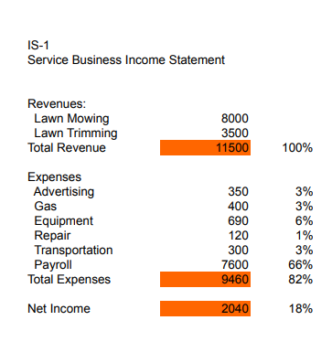
Directions: Look at the Income statement to the Right to calculate the component percentages.
- Total Revenue = $11,500
- Total Expense = $9,460
- Net Income before taxes = $2040
To the left of your totals is called a component percentage. This is what percentage of your revenue is spent on each category. Example. It can be stated that 3% of your total revenue is being spent on advertising. You can breakdown by category or by total.
What percentage of your income is spent on total expenses?
9,460/11,500 =
What percentage of revenue was considered net income?
2040/11,500 =

- Based on this data from the statement on the previous page, do you think this business is in a good place financially (82% of revenue spent on expenses, and 18% as income?)
Why or why not?

- If this was your company, what area would you try to fix to increase the amount of net income coming from revenue?

Directions: For Juan Coulter Calculate his total Revenue, total operating expenses, and Net profit in the left box on the total lines. On the right box, or the second column, calculate the component percentages. In addition, answer the questions below.
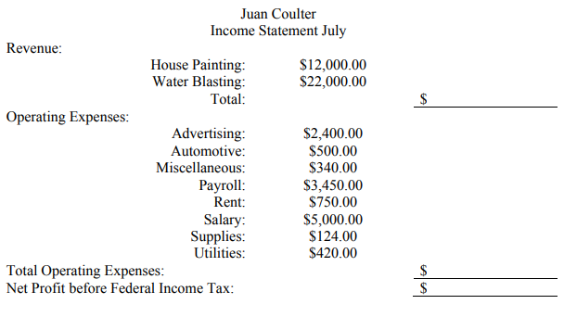
Totals:
Component %

- Based on this data from the statement for Jaun, do you think this business is in a good place financially?

- Why or why not?
- In this example, the business receives more than one type of revenue stream. You can also calculate a component percentage on revenue.
What percentage of the total revenue is from house painting?
What percentage is from Water Blasting?
- If this was your company, what area would you try to fix if anything?

Directions: For Richard Shaw calculate his total Revenue, Operating Expenses, and Net profit in the first column. For the second column, calculate his component percentages for Each expense, third column the percentage for each section. In addition, answer the questions below.
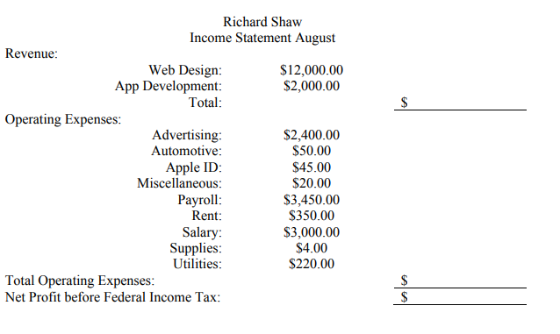
Component %

Totals:
- Based on this data from the statement for Richard, do you think this business is in a good place financially?

- Why or why not?
- What percentage of the Revenue is from Web Design?
What percentage is from App Development?

- If this was your company, what area would you try to fix if any?

Directions: For James Weaver calculate his total Revenue, Operating Expenses, and Net profit in the first column. For the second column, calculate his component percentages for Each expense, third column the percentage for each section. In addition, answer the questions below.
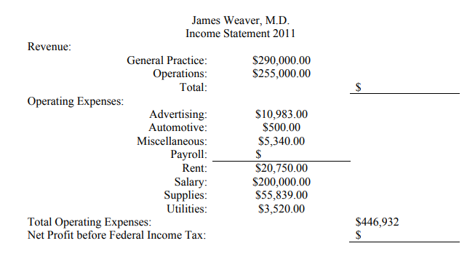
150,000
Component %

- Based on this data from the statement for James, do you think this business is in a good place financially?

- Why or why not?
- What percentage of total Revenue Expenses?
- What percentage of total Revenue is Net Profit?
- What If this were your company, what areas would you try to fix to increase the amount of net income coming from revenue?

- According to the video investors will look at three things to determine if they would invest ( repeat question from page 1)
- Circle the numbers on the Income statement below that you would look at as an investor to answer number three
- Based on the sample you have below, would you invest? Why or why not?

